|  |
| --- |
|  |
| **Relationship Looking** |
| Project introduction |
|  |
| **Project code: RSL** |
| **Document code: RSL_PI – <v1.0>**    Record of change  *A - Added　M – Modified　D – Deleted   |  |  |  |  |  | | --- | --- | --- | --- | --- | | Effective Date | Changed Item | A* M, D | Change Description | Revision Number | | 2015/05/20 | Create new | A | Create document | 0.1 | |  |  |  |  |  | |

## 1. Project Information

* Project name: **Relationship Looking**
* Project code: **RSL**
* Project group name **: 4M1T**
* Product type: **Website Application**
* Timeline: **From 11th May 2015 to 26thAug 2015**

## 2. Project members

### 2.1. Supervisor

|  |  |  |  |  |
| --- | --- | --- | --- | --- |
|  | **Full name** | **Phone** | **E-Mail** | **Title** |
| Supervisor | Trần Bình Dương | 0936168165 | [DuongTB@fpt.edu.vn](mailto:DuongTB@fpt.edu.vn) | Lecturer |

*Table 1.1: Supervisor information*

### 2.2. Team members

|  |  |  |  |  |  |
| --- | --- | --- | --- | --- | --- |
|  | **Full name** | **Student code** | **Phone** | **E-mail** | **Role in Group** |
| 1 | Nguyễn Hoàng Nam | SE02771 | 01696234558 | [NamNHSE02771@fpt.edu.vn](mailto:NamNHSE02771@fpt.edu.vn) | Leader |
| 2 | Đào Duy Thắng | SE02906 | 01649608433 | [ThangDDSE02906@fpt.edu.vn](mailto:ThangDDSE02906@fpt.edu.vn) | Member |
| 3 | Nguyễn Văn Sáng | SE02668 | 01673833970 | [SangNVSE02668@fpt.edu.vn](mailto:SangNVSE02668@fpt.edu.vn) | Member |
| 4 | Nguyễn Văn Cường | SE02837 | 01687388281 | [CuongNVSE02837@fpt.edu.vn](mailto:CuongNVSE02837@fpt.edu.vn) | Member |

*Table 1-2: Team members’ information*

## 3. Background

Social network penetration worldwide is ever-increasing. In 2012, 63.1 percent of internet users were also social network users and these figures are expected to grow. Social networking is one of the most popular online activities with high user engagement rates. Overall, US users spent more than 121.8 billion monthly minutes on social media. According to Statist[1], there are already about 1.79 billion users in social media in 2014. And it is projected to reach about 2.44 billion by 2018. This is surely going to give a large market for Information Technology.

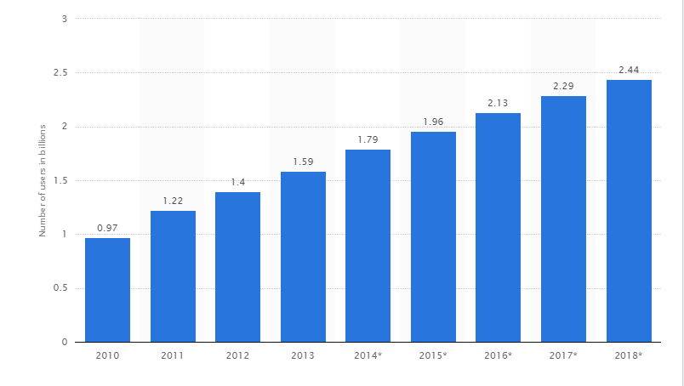

*Figure 1.4-1: Number of social network users worldwide from 2010 to 2018 (in billions)*

According to statistics from the Digital Marketing is youth aged 15 to 24 is subject to the most internet users, with 5 popular activity is reading news, searching for information, listen to music, study and chatting (66% ).



*Figure 1.4-2:* [*Relationship status of Facebooks users in Vietnam*](http://www.slideshare.net/lehoangha304/facebook-market?related=1)

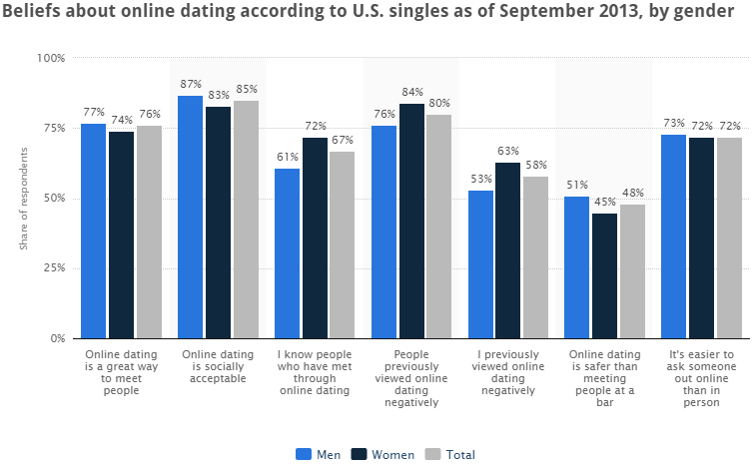More than 4.5 million users of Facebook in Vietnam are single[2].

*Figure 1.4-3:* [*Beliefs about dating online dating according to U.S. singles*](http://www.statista.com/statistics/316481/us-beliefs-online-dating/)

This survey was found that 72 percent of survey respondents thought it was it easier to ask someone out online than in person.

Base on those statistics, we decided to creating a social network to support people finding new friends, looking relationship and chatting with people. We called it “Relationship Looking”

## 4. Literature Review

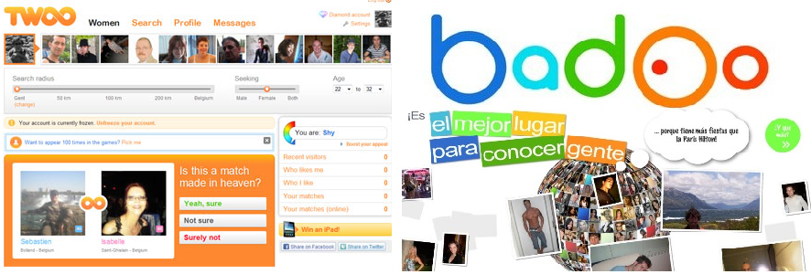Twoo and Badoo are two of the fastest growing places to chat with new people. By the numbers of users (more than 160 million users in Twoo and nearly 250 million user in Badoo), and with 11.9 million monthly active users[3] (Twoo), we can make sure that demand of looking friend and relation online are increase.

*Figure 1.5-1: Twoo and Badoo*

By reviewing some relationship looking websites, we already have gotten main details of those.

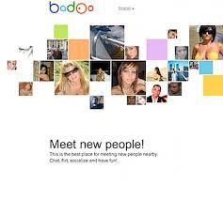

*Figure 1.5-2: Badoo*

* **Badoo**
* The main purposes are chatting, making new friends and **business**.
* Register by link with your Facebook, Microsoft, yandex, google, vk or ok.ru account. It also provides its own register form.
* Link your information from social which you have provided (like age, gender, image, avatar, location, friend, interested…).
* Has **strong verification system** to check your avatar and your account information (manual). You can verify by image (with a form given by this website), by phone, or by link with verified social account suck as Facebook, google, Instagram, twitter, linkedld. If you don’t verify your account, you will be limited many features in this website.
* You can search friend with some filters based on age, gender, interested (compare by tag) and location (by positioning).
* You can like, comment, follow profile of others; chat with them; like, comment their image, album; block or report profile which is unsuitable content.
* The system also allow people vote the best image of day, week, the person who gets the highest position will get **achievement** in his/her profile. However, there are many achievements are waiting you get like the: “the most popular person of week”, “the most friendly person of week”…
* The system provide features allow you know who visited your profile, who liked you, who you have liked.
* Has phone version, suitable for android and iOS.
* **Likeyou.vn**
* Main purposes are social, chatting, dating and making new friends.
* Allows register by linking with Facebook or by its own register form.
* Provides search engine, filter by email, name, age, sex, location… also provide advance filter to help users get the best results.

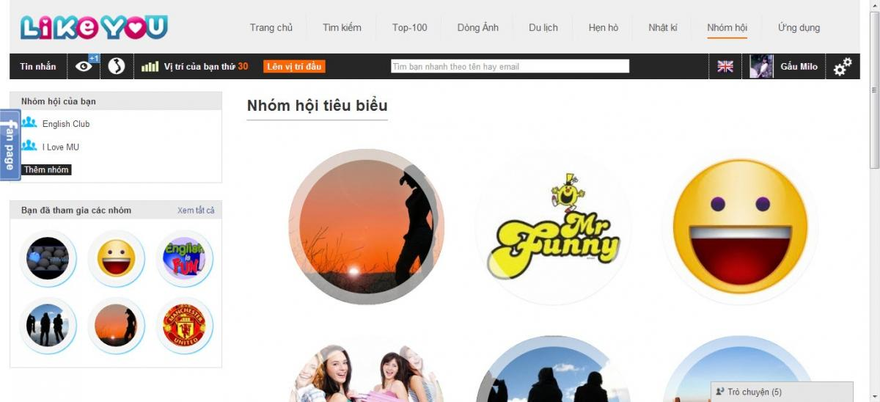

*Figure 1.5-2: Likeyou*

* Collect user’s information via available questions.
* User can chat with others user, like, comment their profile, topics; report violent or unsuitable profile. User can share their images, write diary and share with others (optional).
* By voting, the system ranks and shows top 100 best profiles to the users.
* You can create your own group and invite friends join it - same Facebook group.
* Provides some tips to date people.
* You can create your own topic to request dating. The mandatory of topic must has name, date, description, gender of target, location (optional)… and some optional information.
* The admin sets dating offline and inform to the website as topic with the location and fee to join the dating offline. User can register that dating offline at the website.
* There are other items such as relax corner, news, travels, apps games in the website.
* **Dreaminlove.com**
* Main purposes are social, chatting, dating and making new friends.
* Functionality invite friends joined the website through email
* Provides search engine, filter by age, sex, habitat, connection and keyword (Name, Nickname…) and you can request they has or hasn’t their photo. Provide advance filter to help users get the best results.
* Functionality display your friends list, online member.
* Functionality mailbox: user can receive and send mail for member of website, Can review the folder: sent messages, received messages.
* Functionality “Nice Photo”: photos with the most views will be displayed
* **Mini games**: User can play mini games of website. Can gaming with friends.
* Blogs: User can writing us blogs, Comments below the posts of other members.
* Group: The members can founded the group with its own purpose. The members of group will talk to each other in their group. User can chat group.
* User can update basic information, personal information, and partner information to check the relevance between members.
* Chat function allows 2 people chatting together.
* User can send postcard for other member to get acquainted.
* Can feedback for admin if you have the problem.
* Verify you photo.
* Link with Facebook, mail…
* **Twoo.com**



* “Inquiry” function allows users to ask, answer question from another users. Users can find some friend have conformity personality.
* Links with Facebook, google plus…
* “Representative photo browsing” function requires users make V-sign when taking picture.
* Show information like “people you like”, “people like you”, “people you know”, and “appropriate people”.
* Comments, likes photo of other people.
* Function allows users to find out personality, figure, and style… of other people
* “Chat” function allows 2 people or group of people interact with other people.
* Search by radius help users find out nearly users.
* **Flirchi.com**
* **“Secret dating” section collects many interesting and exciting story about dating.**
* **Function send random message to any 50 people.**
* “Chat” function allows 2 people chatting together. Can use emoticons in chatting.
* Gift functional: You can send gift for your friend to express concerns.
* **Function evaluate photo of other people through the level "cute", "beautiful", "luxurious", "seductive".**
* Function "People nearby". Website will take your address on google map, and display address of people that their near you in 15km radius.
* Mobile version: IOS, Android and other phone browsers.
* Activate VIP account ->business.
* Links with Facebook, mail, Vkontakte App.
* **Hentocdo.vn**
* Search function are convenient (gender, date of birth, height), data rate speed are fast
* Index page arrangement is reasonable.
* “Secret dating” section collects many interesting and exciting story about dating.
* “Movie dating” section stores information about upcoming movies on cinemas. 2 people or more can see and schedule to go to cinemas.
* “Inquiry” function allows users to ask, answer question from other users. Users can find some friend have appropriate personality.
* “Chat” function allows 2 people or group of people interact with other people.
* Hold meeting for users.
* Links with Facebook, google plus…

## 5. Proposal of System

### 5.1. Our proposal system

After review those characteristics of websites, they have their own advantages and disadvantages, so we came to an agreement about which functions our website should support to inherit their strong points and reduce their limitations:

BASIC FUNCTIONS:

* Allow user to connect to another social network account (Facebook, Google+, and Twitter).
* Allow user to post *“Picture”* to their personal page. Each *“Picture”* is a collection of their image description, comment, likes.
* Allow user get verified by phone, image or national ID (based on our rules)
* Allow user to view their personal information page and other uses’ page.
* Allow user to interact with other user.
* Allow user to chat with other if they accept your request chatting.
* Allow user to vote, block, or report other profiles.
* Allow user find friend by many filter.
* Show the most profile conformity with use profile by our algorithm based on user information.
* Show top profiles have most likes.
* Allow user to manage their personal information page
* Allow user to manage process their following.
* Allow user to remove follow another user
* Allow user to view all person who they are following
* Provide achievements to motivate users “makeup” their profile such as “best profile of week”, “best profile of month”...
* Suggestion new friends.

However, due to the limitation of team’s effort, we will not implement these following functions, although we are aware that they are also important to a social network

**OUT OF SCOPE FUNCTIONS**:

* Conference chatting
* Entertainment corner suck as games, share travel experiences.

Finally, we use some new approaches to solve the problems stated. Having aware of the emergence of new technologies, we aim at applying them to our project.

|  |  |  |  |  |  |  |  |  |  |
| --- | --- | --- | --- | --- | --- | --- | --- | --- | --- |
|  | | | Badoo | Likeyou | Dreaminlove | Twoo | Flirchi | hentocdo | My web |
| Chat | 2 people | | x | x | x | x | x | x | X |
| More people | |  | x | x |  |  |  |  |
| Search | Basic search | | x | x | x | x | x | x | X |
| Advance search | |  | x | x | x |  | x | X |
| Search by positioning | | x |  |  |  | x |  | X |
| Mini game | | |  | x | x |  |  |  |  |
| Make friend | | | x | x | x |  |  |  |  |
| Blogs | | |  |  | x |  |  |  |  |
| Comment | | Comment profile | x | x | x | x |  | x | x |
| Comment photo | x | x | x |  |  |  | x |
| Dating | | |  | x |  |  |  | x |  |
| Following-follower | | |  | x | x | x | x | x | x |
| Album photo | | | x | x | x | x | x | x | x |
| Block user | | | x | x | x | x | x | x | x |
| Report user | | | x | x | x | x | x | x | x |
| Feedback | | | x | x | x | x | x | x | x |
| Decentralized user | | | x | x | x | x | x | x | x |
| Top | | User |  | x | x | x | X |  | x |
| Like photo |  | x | x |  |  |  |  |
| The news | | |  | x |  |  |  | x |  |
| Find out personality, figure, and style… of other people | | |  |  |  | x |  |  | X |
| Send random message to any 50 people. | | |  |  |  |  | X |  |  |
| Link with other social web (facebook, google…) | | | x | x | x | x | X | x | x |
| Version for mobile (Android, IOS…) | | | x | x |  | x | X |  |  |
| Verify avatar | | | x |  | x | x |  | x | x |

### 5.2. Introduction about our proposal system

The core idea of the system is helping people getting new friends and suggest the best fit with them to advance a relationship. The information are completely made by user and process by system. Therefore users are no longer wasting their time to search information. Base on provided information, the systems also can choose the best fit with each user. With the verification system, the user also feels more safely and comfortably.

1. <http://www.statista.com/statistics/278414/number-of-worldwide-social-network-users/>
2. [http://www.slideshare.net/lehoangha304/facebook-market?related=1](http://www.slideshare.net/lehoangha304/facebook-market?related=1http://www.slideshare.net/lehoangha304/facebook-market?related=1)
3. comScore, January 2014 